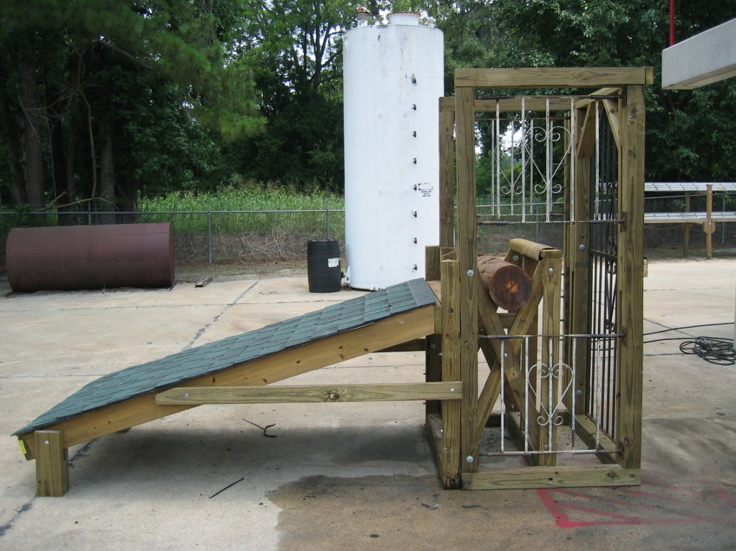
THE “TRUCKMUN”
The “Truckmun” Prop was designed and developed to enhance Truck Company skills in vertical ventilation, forcible entry, hand tool usage; power saw discipline and control, forcible entry operations, and utility isolation. The “Truckmun” features evolutions involving vertical ventilation chopping skills, chain saw operations, K-12 saw usage/control, and gas meter utility isolation using a spanner wrench or similar such hand tool.
The “Truckmun” was constructed using treated 4” x 4” timbers, 2” x 4” and 2” x 6”’s for longstanding resistance against the weather. All components have been assembled using carriage bolts for disassembly and mobility purposes. All permanent sections (i.e. 4” x 4” framing) is constructed using 6 ½” lag bolts.

CONSTRUCTION / MATERIALS
The supplies needed to construct the “Truckmun” include:
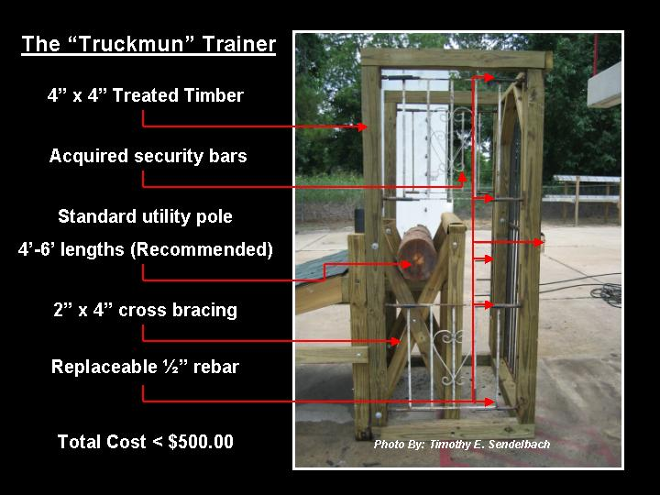
(7) 4” x 4” x 8’
(3) 2” x 4” x 8’
(1) 4’ x 8’ x ½” CDX plywood
(8) 6” x ½”10” x ½” Carriage bolts
(10) 8” x ½” Carriage bolts
(8) 6 ½” x ½ Lag bolts – connects 4” x 4” framing
(3) Sections of All Thread ½” x 24” – Cut to join 4” x 4”’s at the rotational cut section
(2) Bundles of standard roofing shingles
(1) 4’ x 8’ covering of standard roofing tar paper
(1) 1lb box of standard roofing nails
(1) 48” section of utility pole – will need multiple sections for each course of instruction
(4) Security bars (Window sections)
(1) Gated door section
(6) ½” x 8’ sections of rebar
(20) Thumb screws (used to hold replaceable rebar sections)

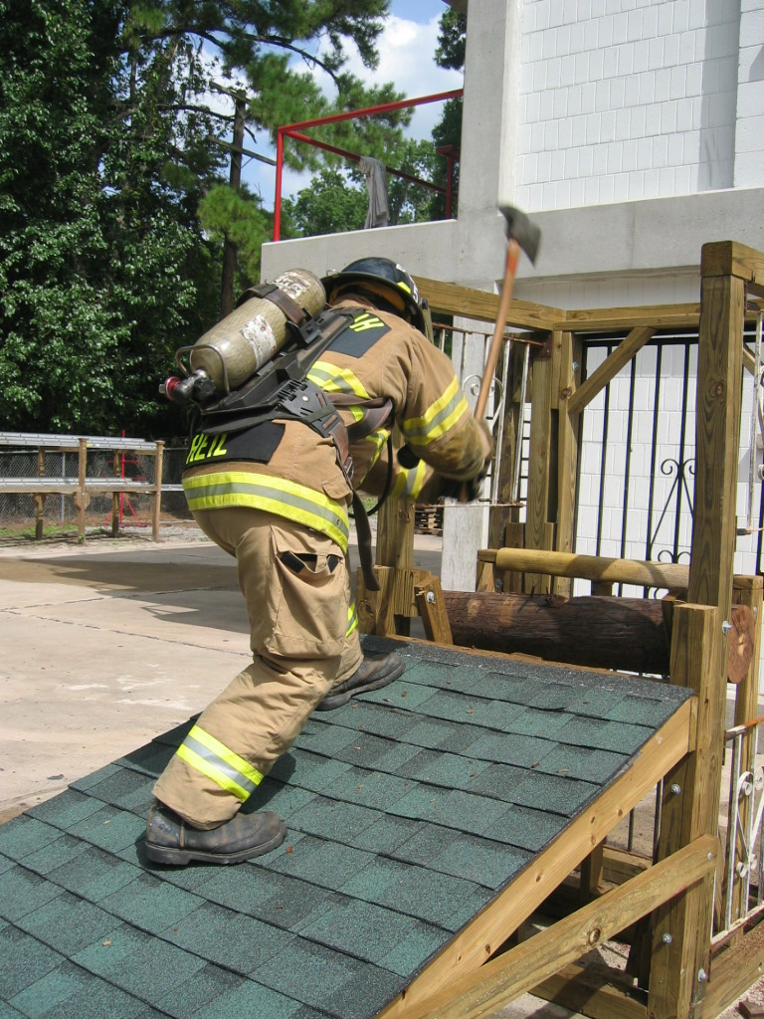
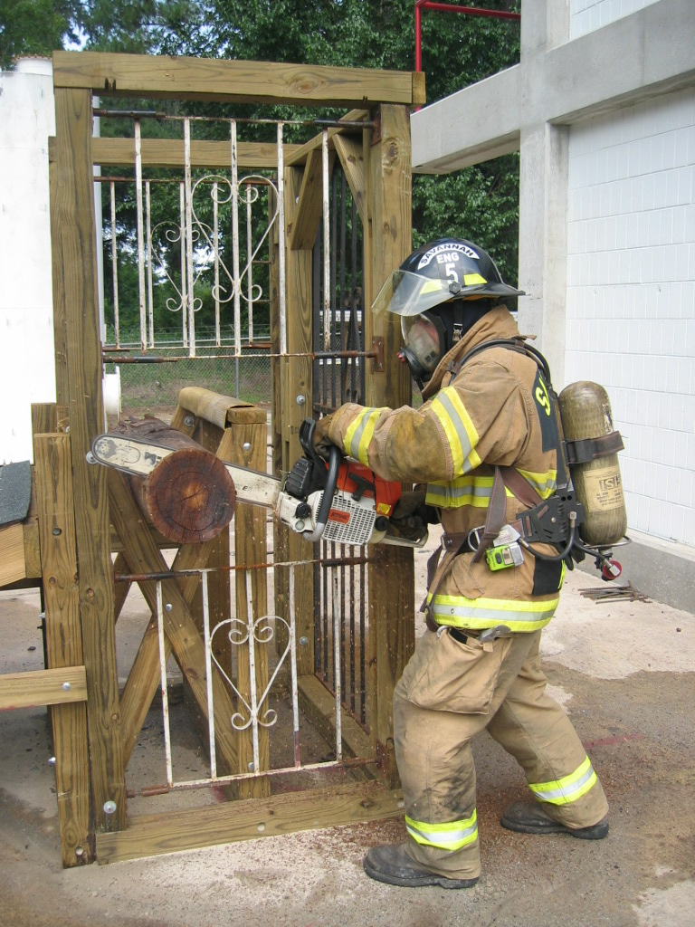
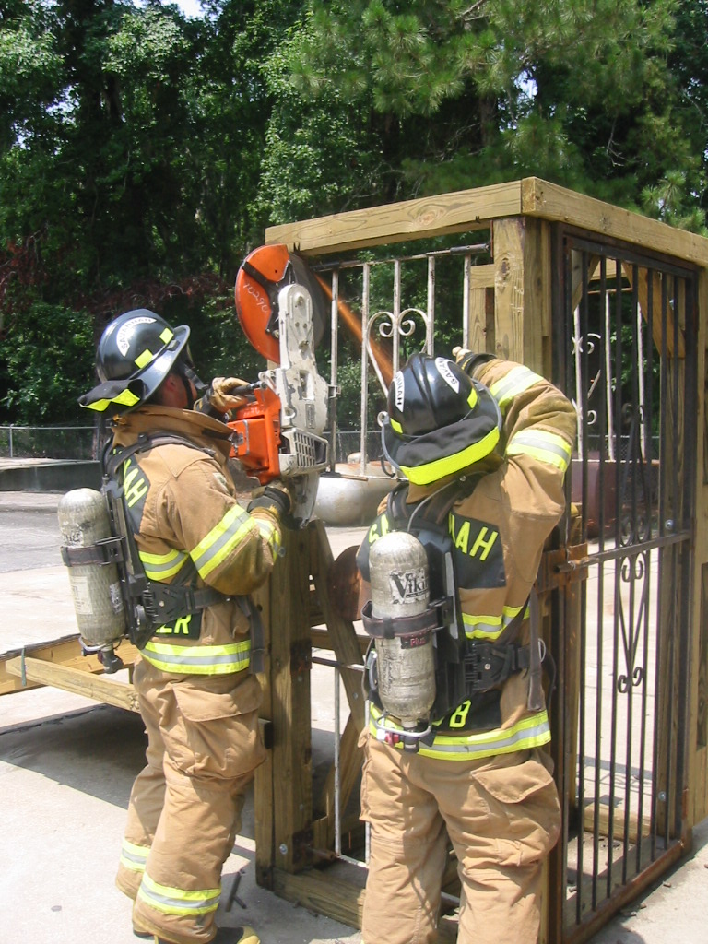
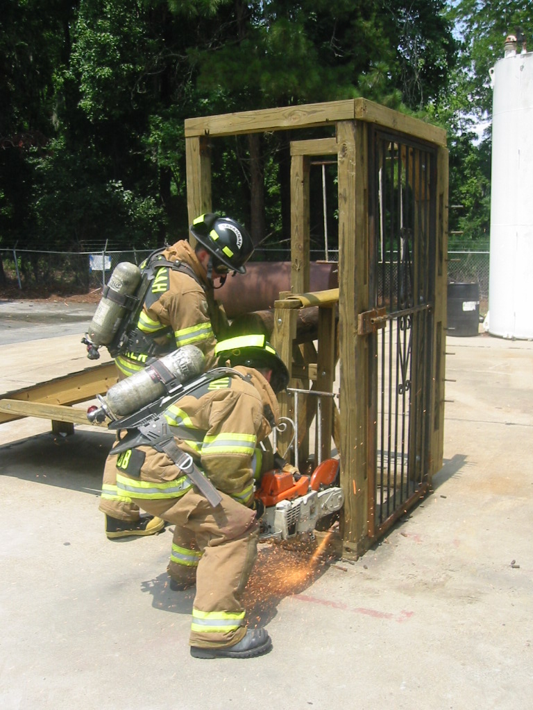
RECOMMENDED DRILLS:

Step 1 – Using a pick head axe - chop utility pole for 2 minutes.
Step 2 – Using a standard chain saw – cut (1) 2” section off the end of the utility pole
Step 3 – Using a K-12 saw with a metal blade – cut the four sections of replaceable rebar (security bars)
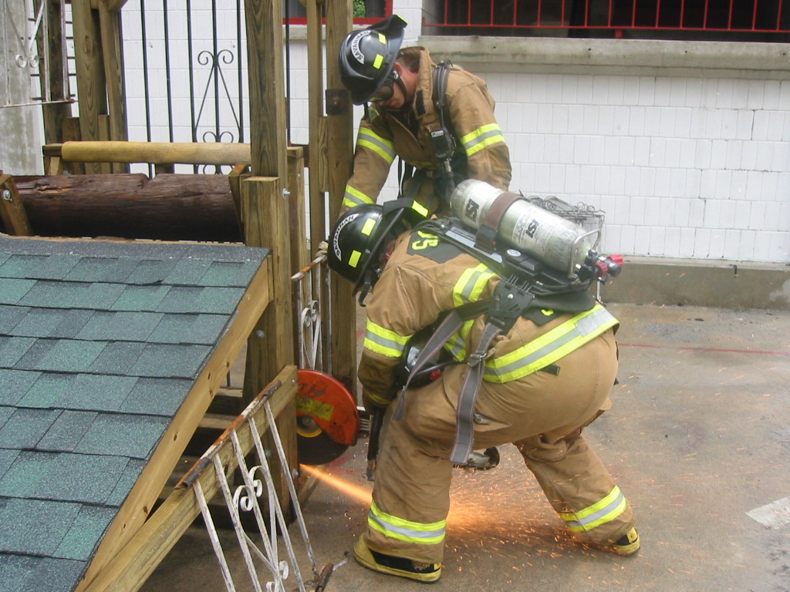
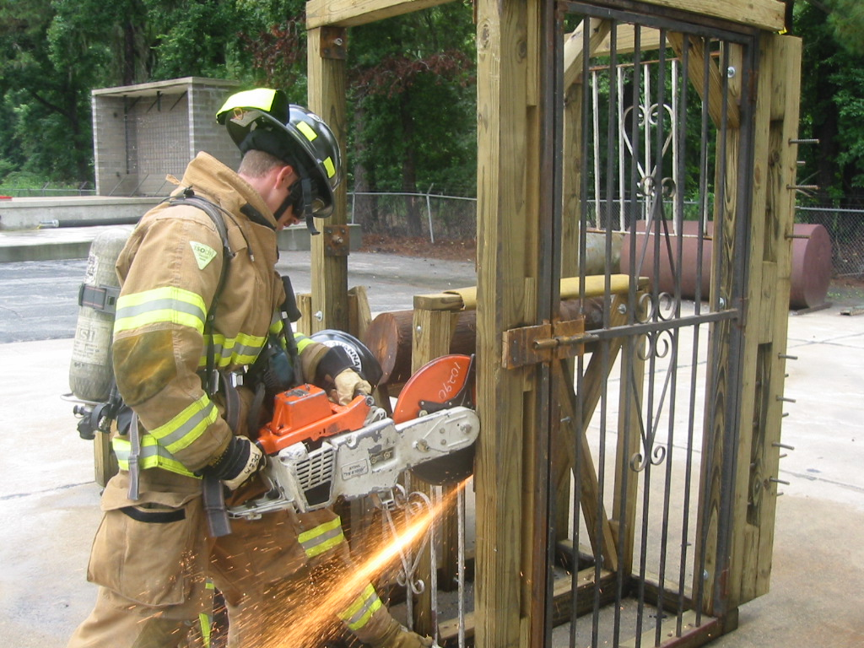
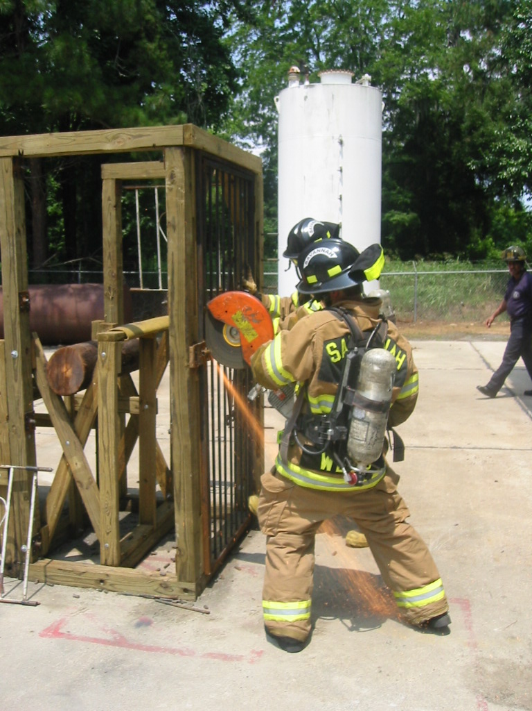
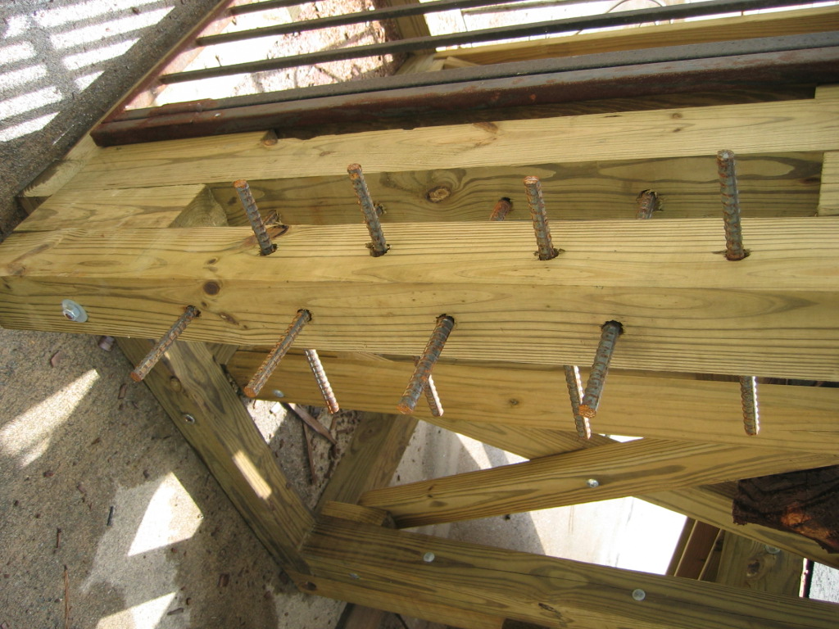
Step 4 – Using a K-12 saw with a metal blade – cut the replaceable section of rebar to force the gated doorway

Step 5 – Using a K-12 saw with a metal blade – cut the replaceable sections of rebar using rotational cuts

Step 6 – Using a K-12 saw with a metal blade – cut the four sections of replaceable rebar (security bars)

Step 7 – Using a standard spanner wrench – secure the utilities

Rotational Cut Section

Gated doorway cut

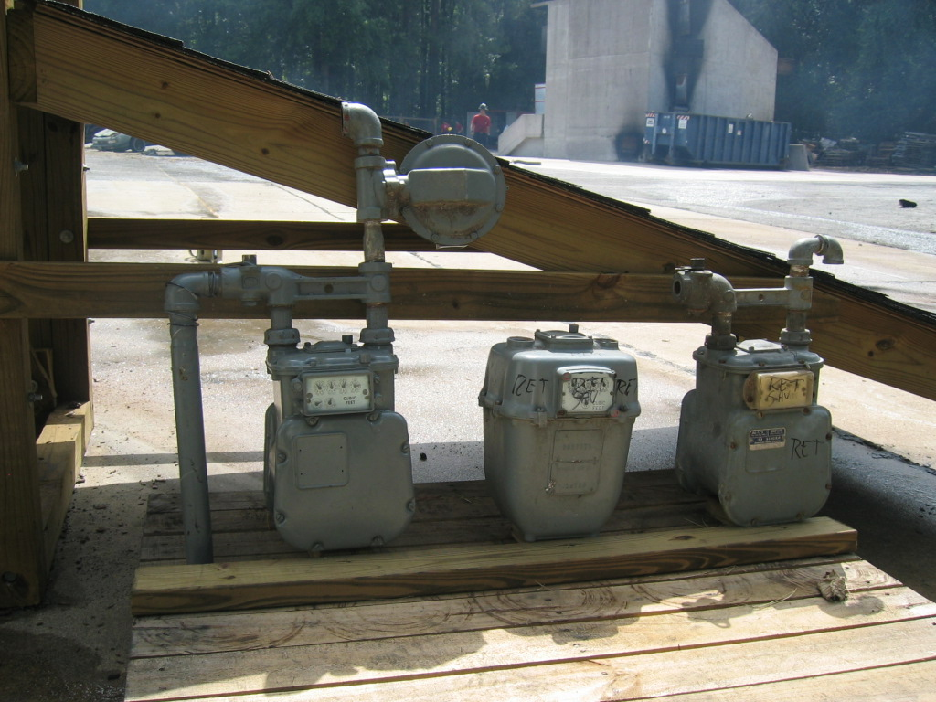
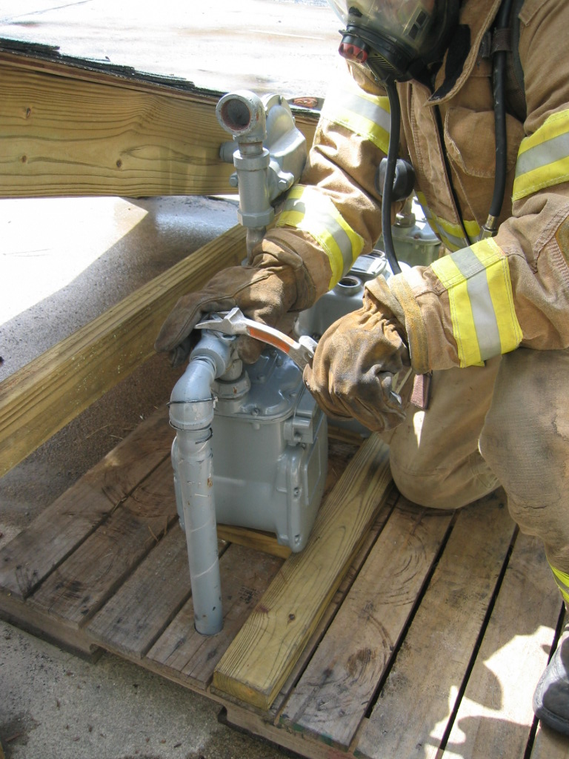
CREDITS:
The “Truckmun” Prop was designed and constructed by Savannah Fire & Emergency Services Training Division, Master Firefighters Todd Heil, Roy Howard and Chief of Training Tim Sendelbach

Additional information about the use and construction of this prop can be obtained by e-mailing Chief Sendelbach at tesendelbach@msn.com.

Utility Isolation Prop

